ACCESS CONTROL AND FILE PERMISSIONS
Assignment Submission
Name | Rani Kumari
Roll Number | B25BS1270
Cohort | 3

Task 1: Terminal Task — Permission Setup
The directory /home/iit_lab is created in the Linux terminal. Four files are created in that directory and permissions are assigned with chmod. The final permissions are verified using ls -l.

Commands used
mkdir -p /home/iit_lab
cd /home/iit_lab
touch student_grades.txt admin_config.txt shared_notes.txt setup.sh
chmod 644 student_grades.txt
chmod 600 admin_config.txt
chmod 666 shared_notes.txt
chmod 755 setup.sh
ls -l /home/iit_lab

Permission assignment and explanation
File | Permission | Mode | Explanation
student_grades.txt | rw-r--r-- | 644 | Owner can read/write; group and others can read.
admin_config.txt | rw------- | 600 | Only the owner can read and write.
shared_notes.txt | rw-rw-rw- | 666 | Everyone can read and write; suitable only for this demonstration, not sensitive files.
setup.sh | rwxr-xr-x | 755 | Owner can read/write/execute; group and others can read/execute.
Permission values: read (r) = 4, write (w) = 2, execute (x) = 1. For example, 755 gives the owner rwx (4+2+1) and group/others r-x (4+1).

Terminal evidence
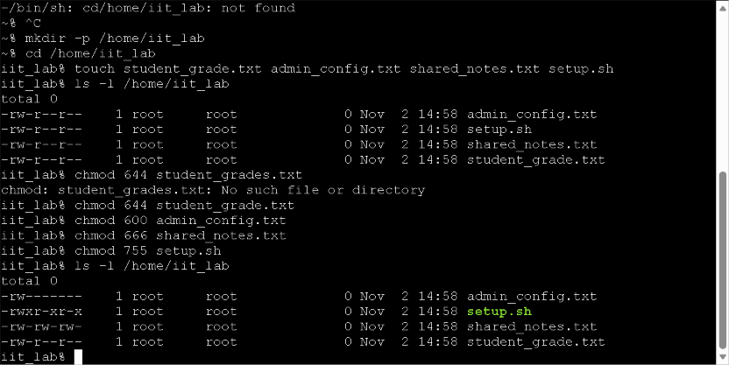
Screenshot supplied during the terminal work. It shows the permission settings, but the student filename is still student_grade.txt (singular).
FINAL EVIDENCE REQUIRED: Before submission, run 'mv student_grade.txt student_grades.txt' and then 'ls -l /home/iit_lab'. Replace/append this screenshot with the corrected final output showing student_grades.txt.

Task 2: Colab Extension — CIA Triad Simulator
The Activity 3 simulator is extended with exam_paper.txt. Its access control lists permit only admin to read and write the file.
authorized_readers = ["admin"]
authorized_writers = ["admin"]

Access scenarios and recorded results
Scenario | User | Operation | Result
1 | rahul | Read secret_data.txt | Allowed
2 | rahul | Write secret_data.txt | Denied
3 | student | Read secret_data.txt | Denied
4 | student | Write secret_data.txt | Denied
5 | admin | Read exam_paper.txt | Allowed
6 | student | Read exam_paper.txt | Denied
7 | student | Write exam_paper.txt | Denied
8 | admin | Write exam_paper.txt | Allowed
Summary: 8 total attempts; 3 Allowed and 5 Denied.

Colab execution evidence
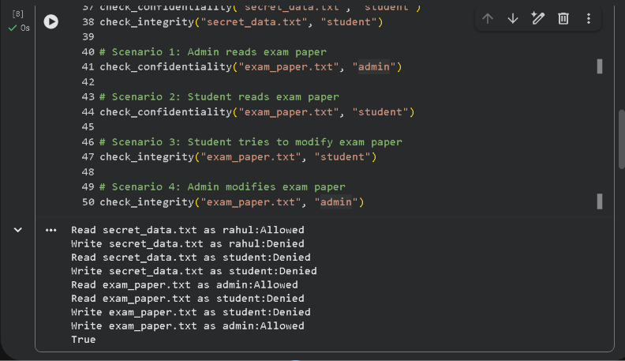

Updated bar chart
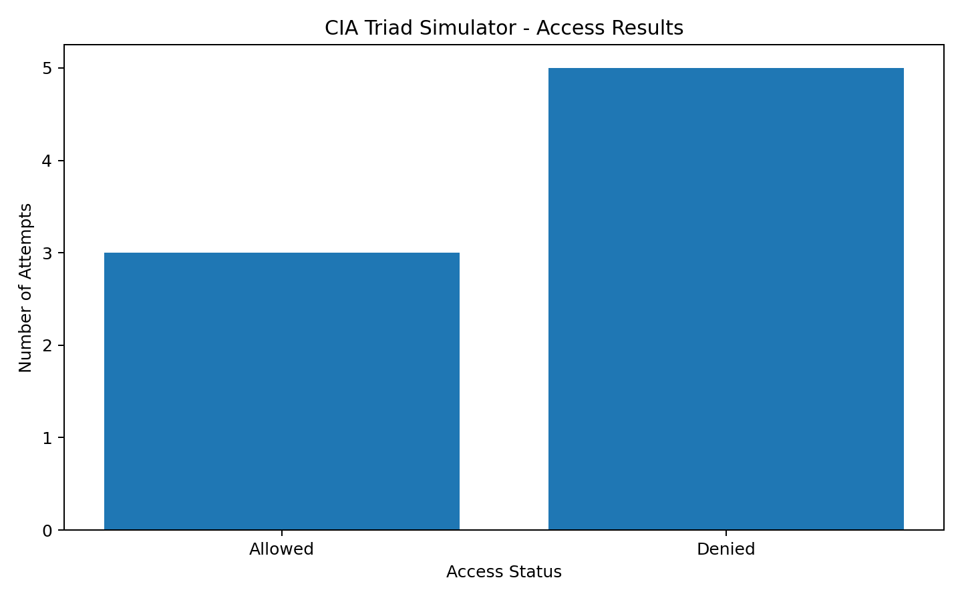

How the simulator enforces permissions
For read requests, check_confidentiality() checks whether the username is in authorized_readers. For write requests, check_integrity() checks whether the username is in authorized_writers. A listed user receives Allowed; an unlisted user receives Denied. Each result is recorded and counted in the chart. This is an application-level ACL simulation.

Updated Python code
files = {
"secret_data.txt": {
"authorized_readers": ["admin", "rahul"],
"authorized_writers": ["admin"],
"content": "Confidential record"
},
"public_info.txt": {
"authorized_readers": ["admin", "rahul", "student"],
"authorized_writers": ["admin"],
"content": "Public record"
},
"exam_paper.txt": {
"authorized_readers": ["admin"],
"authorized_writers": ["admin"],
"content": "Confidential examination paper"
}
}

results = []

def check_confidentiality(filename, user):
allowed = user in files[filename]["authorized_readers"]
status = "Allowed" if allowed else "Denied"
results.append((filename, user, "Read", status))
print(f"Read {filename} as {user}: {status}")
return allowed

def check_integrity(filename, user):
allowed = user in files[filename]["authorized_writers"]
status = "Allowed" if allowed else "Denied"
results.append((filename, user, "Write", status))
print(f"Write {filename} as {user}: {status}")
return allowed

# Original Activity 3 tests
check_confidentiality("secret_data.txt", "rahul")
check_integrity("secret_data.txt", "rahul")
check_confidentiality("secret_data.txt", "student")
check_integrity("secret_data.txt", "student")

# New exam_paper.txt tests
check_confidentiality("exam_paper.txt", "admin")
check_confidentiality("exam_paper.txt", "student")
check_integrity("exam_paper.txt", "student")
check_integrity("exam_paper.txt", "admin")

# Chart for all eight attempts
import matplotlib.pyplot as plt
allowed = sum(1 for item in results if item[3] == "Allowed")
denied = sum(1 for item in results if item[3] == "Denied")
plt.figure(figsize=(8, 5))
plt.bar(["Allowed", "Denied"], [allowed, denied])
plt.title("CIA Triad Simulator - Access Results")
plt.xlabel("Access Status")
plt.ylabel("Number of Attempts")
plt.tight_layout()
plt.savefig("cia_access_results.png", dpi=180)
plt.show()

Task 3: Reflection Paragraph — Access Control Model
Proposed model: Role-Based Access Control (RBAC). The paragraph below is a submission draft and must be checked against personal experience with the portal.
Based on my use of the IIT Jodhpur assignment submission portal, the access control model appears to be Role-Based Access Control (RBAC). Students use their student accounts to access course material and submit assignments. Faculty members have role-specific permissions to view submitted work and evaluate or grade it. Students cannot grade submissions or change their marks, while administrative functions are reserved for authorized administrators. These permissions are associated with each user's role rather than being freely assigned by individual users. Therefore, RBAC appears to be the main model describing the portal's access-control arrangement.
IMPORTANT: The assignment requires examples from your actual portal experience. Confirm that you have observed the faculty grading and administrator permissions. If not, edit those claims before submitting; do not present unverified details as personal experience.

Final submission checklist
- Replace the Task 1 screenshot with a final screenshot showing student_grades.txt (plural) and all four permissions.
- Attach/download the updated Google Colab notebook (.ipynb) if the portal requires it separately.
- Confirm that the chart and the eight scenario results are present.
- Verify and personalize the Task 3 reflection using actual portal experience.

